Identification tool for vegetable and marine oils. (example is a marine oil).

ELUTION ORDER AND IDENTIFICATION ON
25M x 0,25mmID 0,2um film of polyethyleneglycol ( wax column).

Errors may exist in the arean from C16:1 to C16:4.

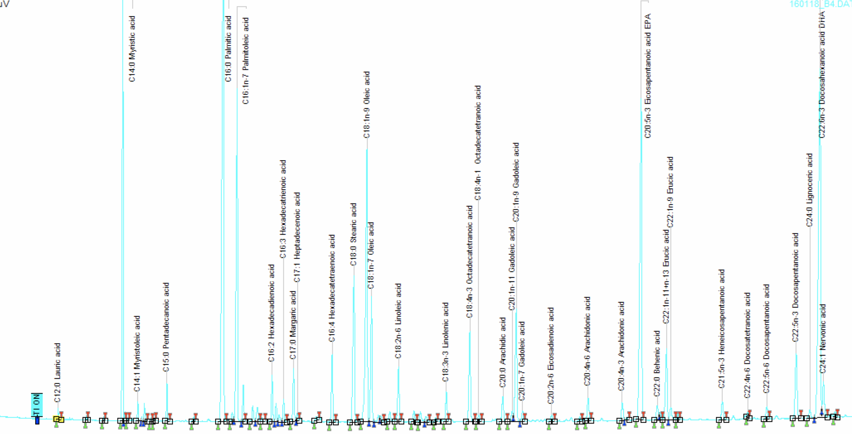
Complete chromatogram.

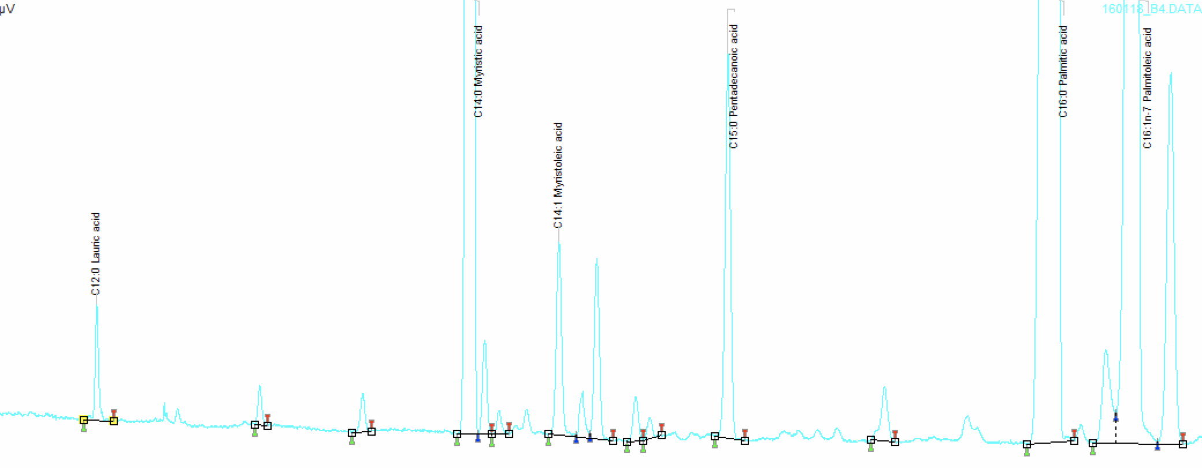
C12:0 to C16:1 section.

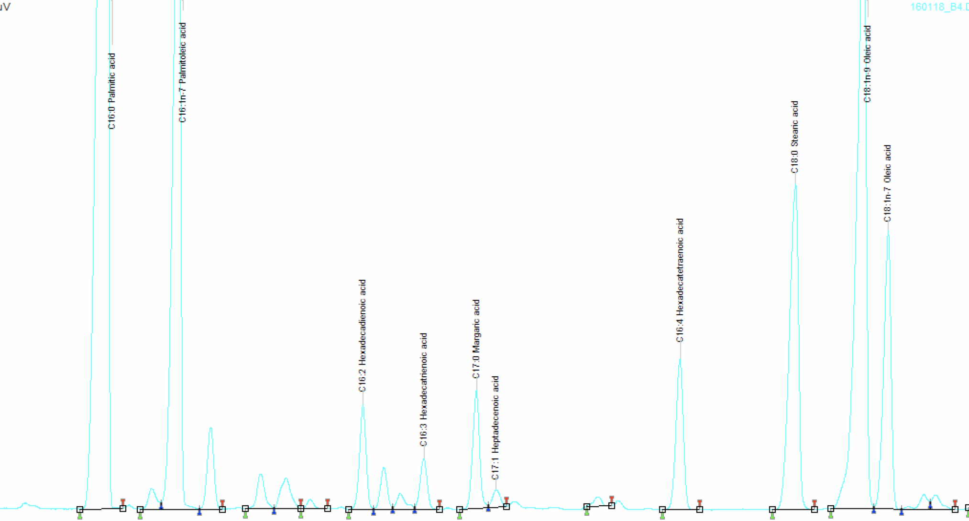
C16:0 – C18:1 section. (small peaks in the middle is a challenging are, may be deviations)

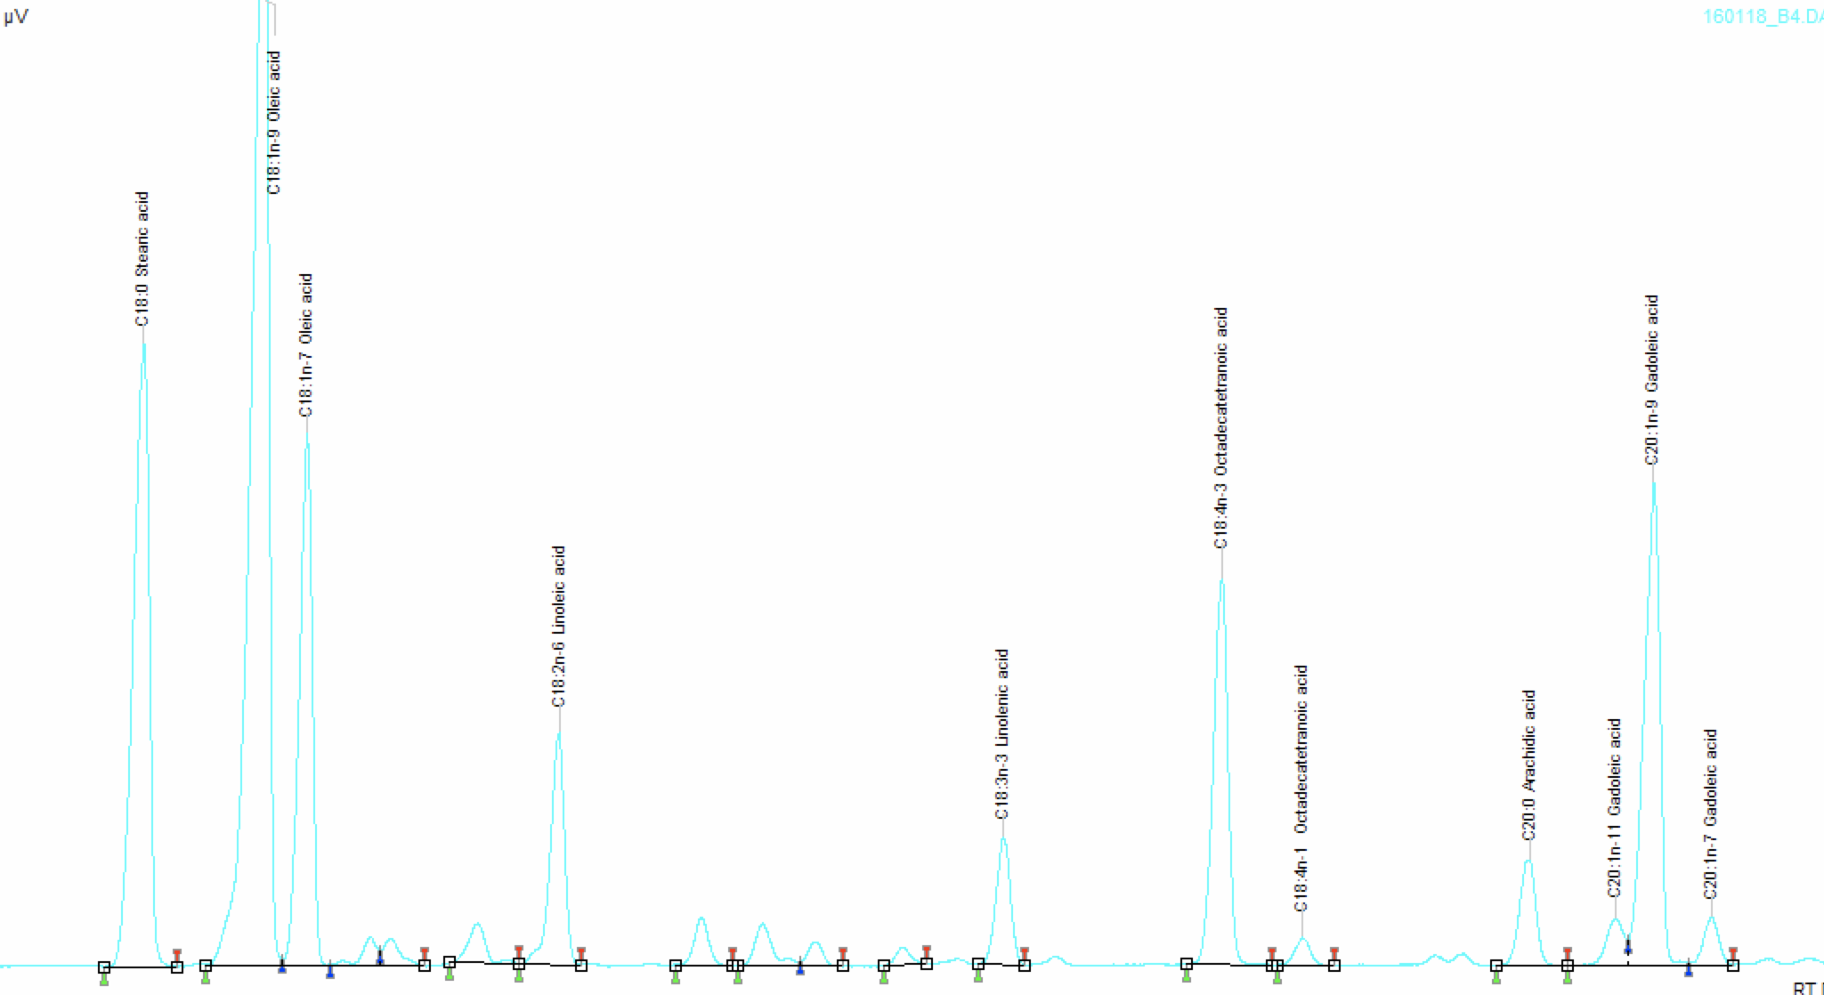
C18:0 – C20:1 section.

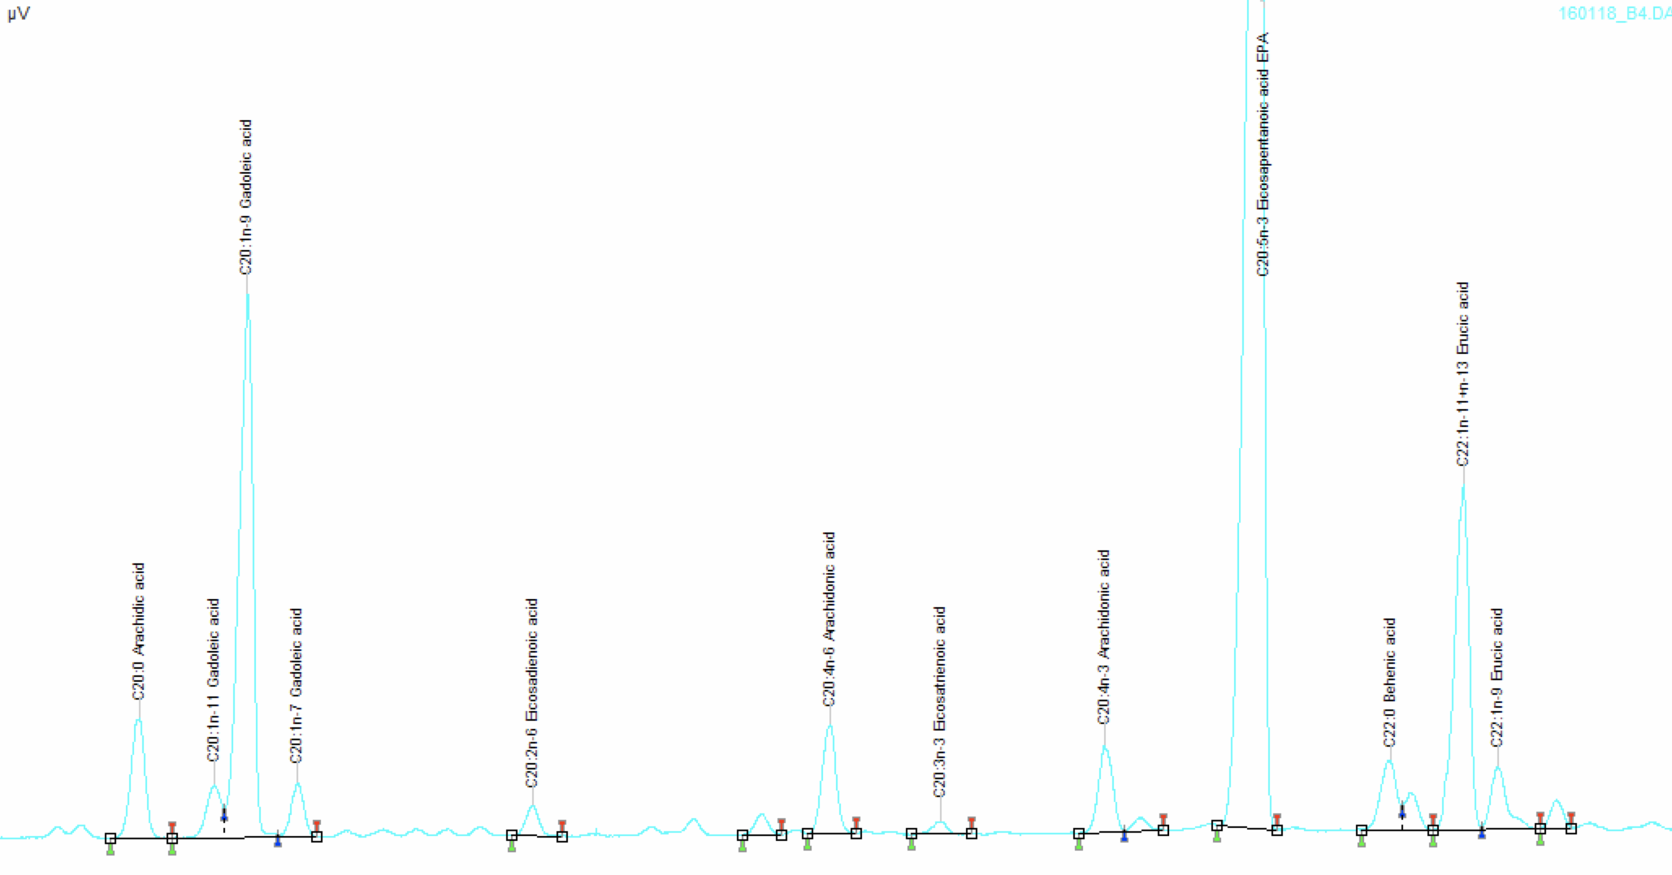
C20-C22:1 Section

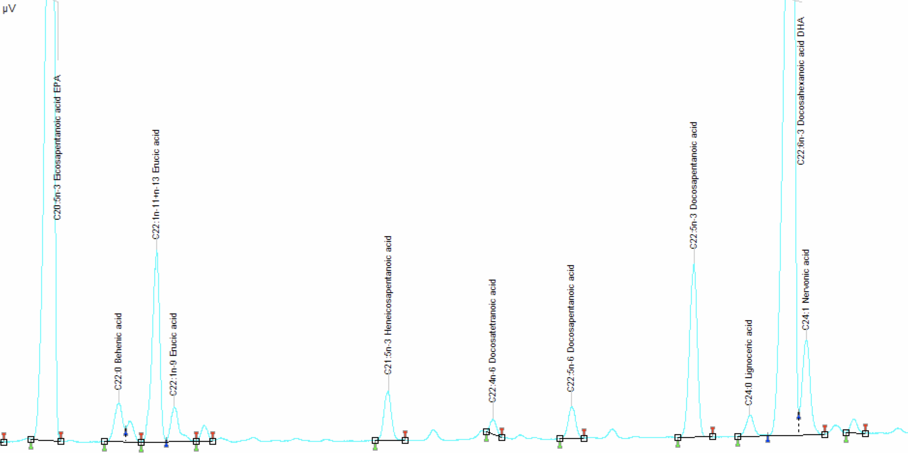
C20:5 – C24:1 Section.

